**Prism iPhone App Feature Set**

**Overview**

Prism is a “mobile first” social discovery platform targeted at students (ages 13-23). It’s goal is to inspire young people with purpose-driven content from institutions (e.g. universities, military, non-profits, luminaries, brands, scholarship foundations). Prism creates a content-driven dialog between students and institutions. It enables institutions to curate inspirational content for students to consume and share. It’s a network for social discovery with a purpose. This tool will help you Capture, Explore and Discover your purpose then Share to create opportunity. Prism will illuminate your passion and help you discover a bright future!

**Global Navigation**

* Home
* Explore
* Activity
* Trust
* Activity Graph
* Profile
* Settings
* Spectrum (end users timeline and categorized content)

**Home**

This feed will serve as the app’s home screen and will display the content added by the user’s selected institutions, followed user’s (public content) and user’s within their Trust. Each piece of content will include:

* Username of publisher
* Time
* Content (image-centric)
* Category (e.g. Inspirations, Experiences, Passions, Aspirations, Achievements)
* Source (if not user generated)
* Map (Foursquare)
* Comments
* Like
* Share
* Repost (End user can add to their Prism)

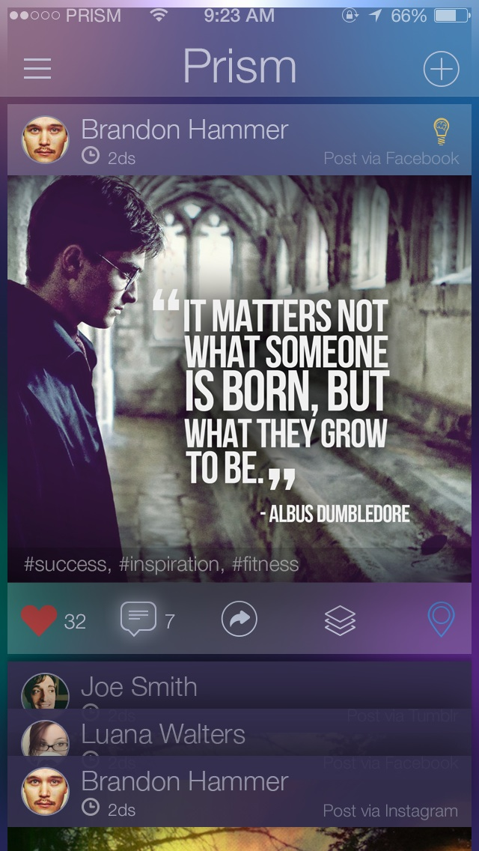

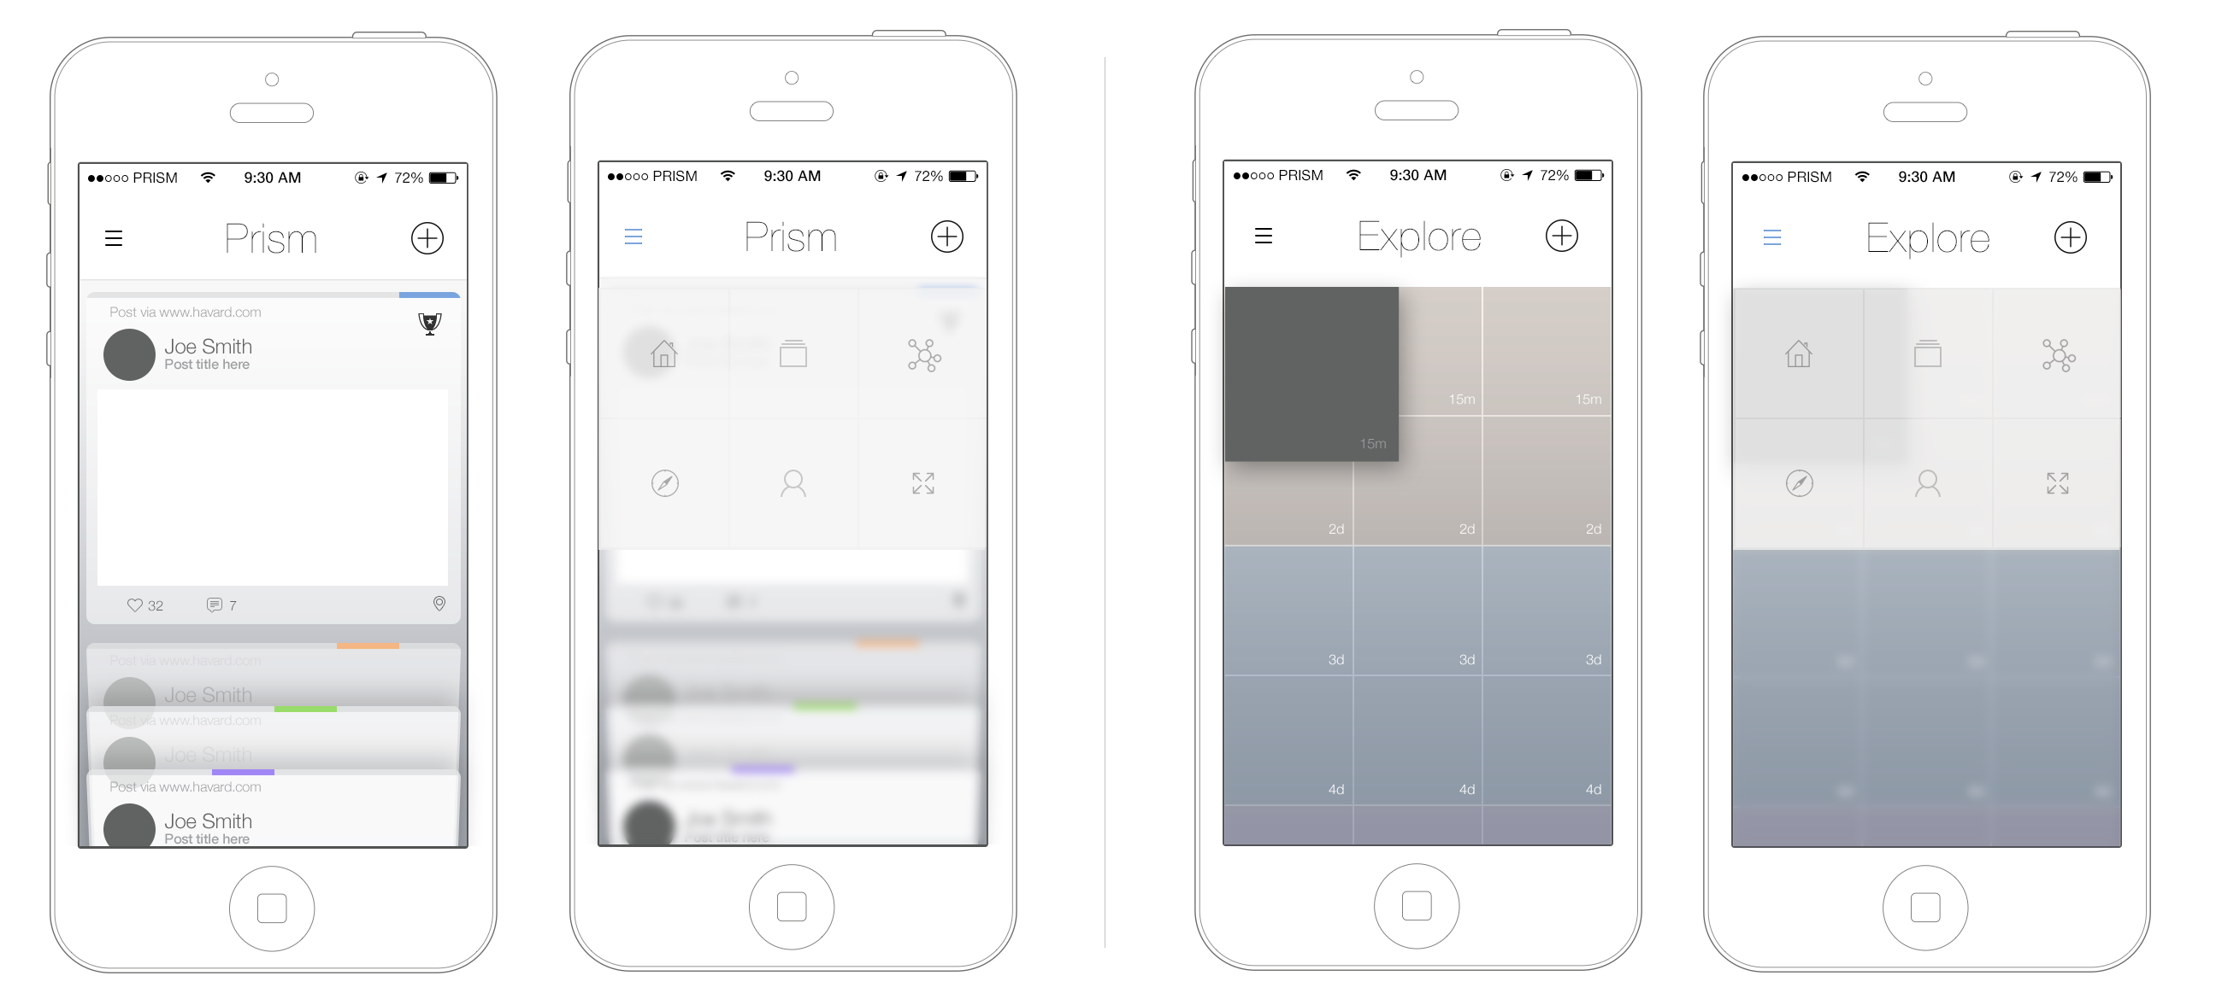

**Explore**

The Explore page will function as the main vehicle to discover new institutions that the user might be interested in engaging with. Initially, the explore screen will show all featured content. The user will be able to search by hashtag or institution name, and can also filter by category (aspirations, etc..) and institutional type. Ordered by most timely. Only public user content will be viewable from the explore page, non-visibly sorted by Latest, Popular or Featured.[[d]](https://docs.google.com/a/higheraltitude.co/document/d/1TPzunpdWq_1FrTwE8zpSQYDXbfBfsiRwWasSudvW-zY/mobilebasic#cmnt4)

Results are displayed as:

* Username of publisher
* Time
* Content (image-centric)
* Category (e.g. Inspirations, Experiences, Passions, Aspirations, Accomplishments)
* Source (if not user generated)
* Map (Foursquare)
* Comments
* Like
* Share
* Repost (End user can add to their Prism)

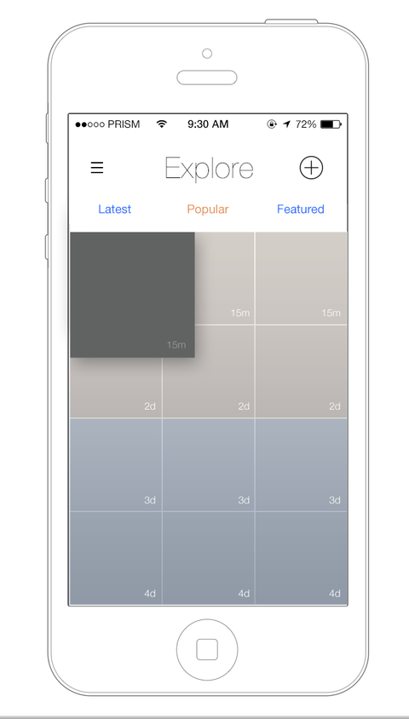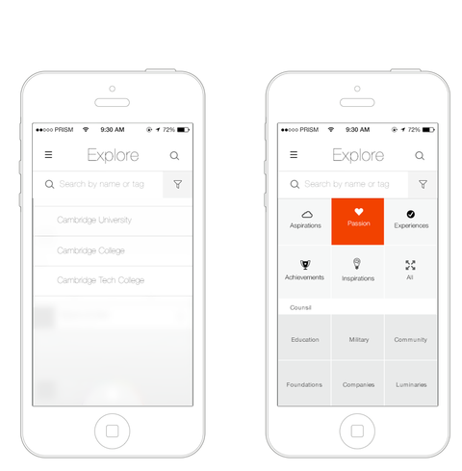

**Activity**

This is where the user will receive and view notifications, requests, accolades and recommendations. A user will see activity from the Prism community (likes and comments). A user will be able to accept/deny requests and council members interacting with them[[a]](https://docs.google.com/a/higheraltitude.co/document/d/1TPzunpdWq_1FrTwE8zpSQYDXbfBfsiRwWasSudvW-zY/mobilebasic#cmnt1).

This section will become even more relevant in v2, but for v1 it will serve as an outlet to notify users of relevant activity within the app. Content will include comments, event alerts, accolades from the user’s Trust.

Fields displayed are: [[b]](https://docs.google.com/a/higheraltitude.co/document/d/1TPzunpdWq_1FrTwE8zpSQYDXbfBfsiRwWasSudvW-zY/mobilebasic#cmnt2) (Based on Time)

* When a post is liked by another user (or “endorsed” by a trust member?)
* When a post is commented by another user
* When a post is reposted by another user
* When a post is shared by another user
* When a trust member comments on the user’s post
* When a trust member sends an accolade
* When another user accepts to join the user’s trust
* When a user receives a new recommendation (insights)
* When a university sends the user a message[[c]](https://docs.google.com/a/higheraltitude.co/document/d/1TPzunpdWq_1FrTwE8zpSQYDXbfBfsiRwWasSudvW-zY/mobilebasic#cmnt3)
* When a user is tagged in a photo
* When a new post is added to a user’s timeline from another network(spectrum)
* When a friend from FB or phone list creates a Prism profile.
* When a university sends an event invitation/reminder (version 2)

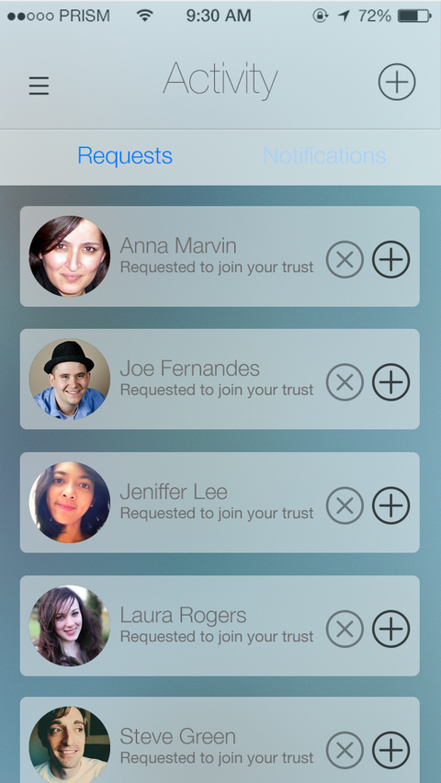 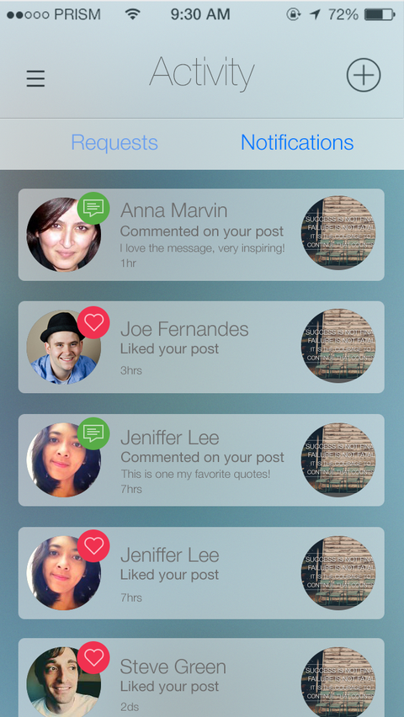

**Profile**

This will be where the user and institutions gathers their timeline of content. There are two ways for a user to add content to their Prism: in app or via connected social sites. From within the app, users should be able to quickly and easily upload content from anywhere within the app. This can be text, photo, video, or link, along with the ability to add a location. Content entered this way must be categorized. It can also be marked as public or private, but will default to private[[e]](https://docs.google.com/a/higheraltitude.co/document/d/1TPzunpdWq_1FrTwE8zpSQYDXbfBfsiRwWasSudvW-zY/mobilebasic#cmnt5). It should take the user to the timeline once entered and have an interesting animation to show entry.

If connected with Twitter, Instagram, Tumblr, FB or Foursquare, content will be pulled from these sites when a user associates a “#prism” tag. The user can also associate a category tag (for example #aspirations) to have it auto categorized. If a user doesn’t use a category tag, the content pulled from other sites will labeled as uncategorized.

The page will be filterable by the categories:

* Aspirations
* Inspirations
* Experiences
* Achievements
* Passions

The Profile will also show:

* Cover photo
* Profile photo
* Username

**Accolades (Profile)**

Profile will include a section for Accolades. Where user can see all accolades received. Accolades come in one form and user is able to see date received and sender. Consider badge-like UI. Users will see their number of accolades and will also be able to send accolades to others.

**Spectrum of Content (Profile)**

Content added from other networks (Twitter, Instagram, Tumblr, Facebook and Foursquare) will be denoted as such.

Content will be displayed as:

* Username of publisher
* Time
* Content (image-centric)
* Category (e.g. Inspirations, Experiences, Passions, Aspirations, Accomplishments)
* Source (if not Prism generated)
* Map (Foursquare integration)
* Comments
* Like
* Share
* Repost

Content added from other networks (Twitter, Instagram, Tumblr, Facebook and Foursquare) will be denoted as such. The Profile will also show the end users posts, followers and who the end user is following. The following will be differentiated by categories (individuals and council).

**Stats (Profile)**

Users will be able to view the quantitative information associated with their private profile from the profile as well, including:

* # of users the user is following
* # of users following the user
* # of posts from the user
* # of accolades
* # of trust members

**Settings (Profile)**

The hub of user data in the app. Home to:

* Push Notifications (turn on or off)
* Username
* Password
* Photo
* Website
* Email
* Sex
* Race/Ethnicity
* Birthday
* Zip Code
* Affiliations to Council (institutions)
* Social Settings
* Connect with Facebook
* Connect with Instagram
* Connect with Twitter
* Connect with Tumblr
* Connect with Foursquare
* EULA
* Privacy Policy
* Terms of Use
* Feedback (via email)

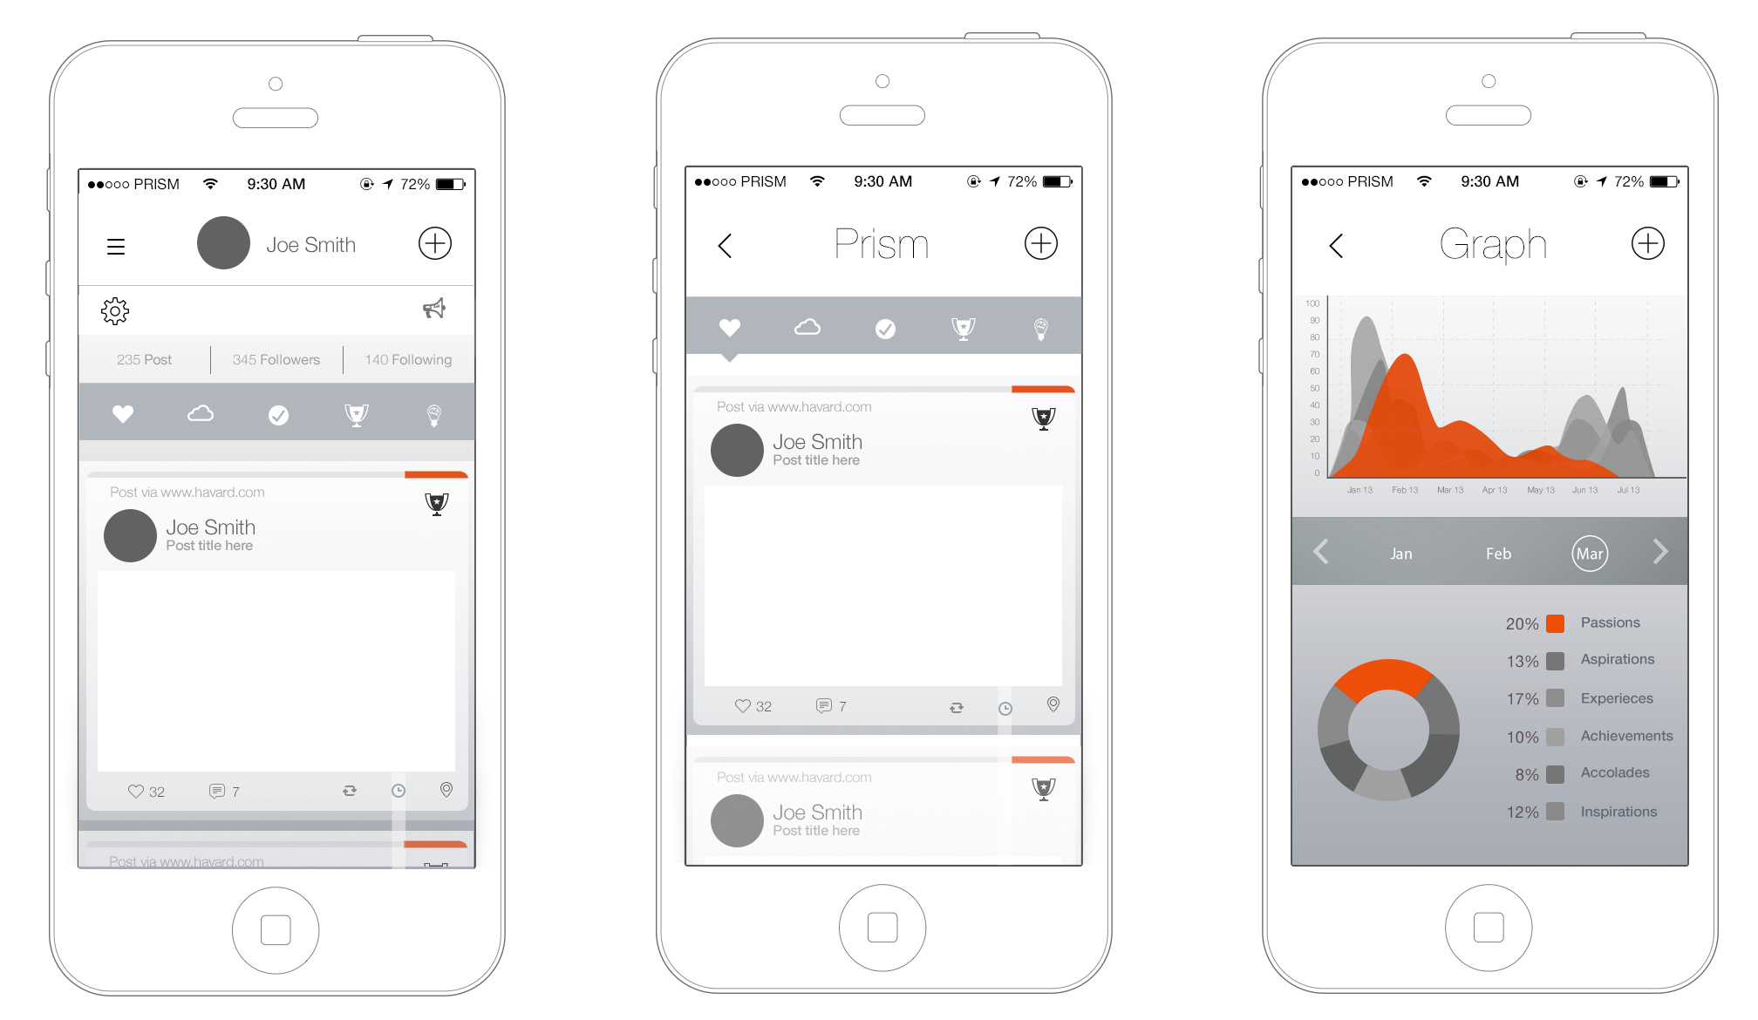

**Graph**

Indicator to show which areas the user is active in (Aspirations, Inspirations, Experiences, Achievements, Passions). The more posts a user has in one of the categories, the higher that visual representation will be. (this should focus on intensity). This graph will be represented over time to give an individual perspective of their use. The graph will default into a weekly measure.

All content, including private, will be counted within these statistics[[l]](https://docs.google.com/a/higheraltitude.co/document/d/1TPzunpdWq_1FrTwE8zpSQYDXbfBfsiRwWasSudvW-zY/mobilebasic#cmnt12). No one will be able to view the content from here, only view the data. (need to included total like content as well - ideally then would take you to liked content)

**Trust**

The trust is only visible to the user. The Trust is a user’s connections within Prism such as parents, teachers, mentors or coaches. These connections demonstrate the strength of the user’s support network (i.e. Trust). Here, users can search for and add new Trust members, or view Trust members’ Prism. The user will be able to visit Trust members Prism from here. Within the Trust section, users can choose to send a message and/or an accolade to another user, one at at time. The top 5 most active Trust members will be visually shown. The position of the trust members should change with their level of activity. An end user will tap on each trust member and see the following:

* Trust member Name
* Trust member Title
* Trust member Avatar (Profile Pic)
* Trust member stats (#following, #followers and #trust)
* Trust member length of membership within user’s trust.
* Trust member meter (this should represent the level of activity with the user this should correlate with the trust members position on the connections)
* Trust member messaging to send an email to trust members.

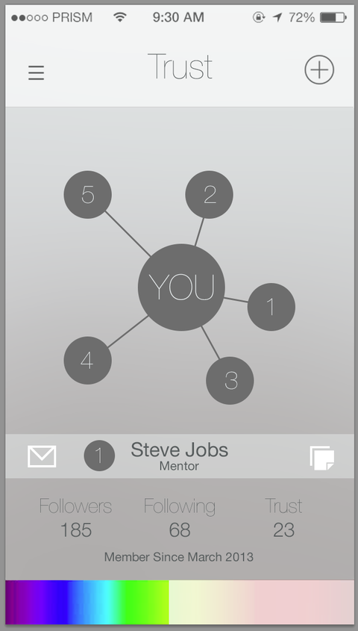

**Prism Council (Institutions)**

Institutions include education, military, community, luminaries, companies, and foundations. These institutions are the principal content creators on Prism. Their goal is to connect with and broadcast their content to the app’s general user base.

The Prism Council can be found in the Explore section, where users can search for institutions they’d like to follow, as well as have the ability to browse and filter by organization type (education, military, community, luminaries, companies, and foundations).

**User Public Profile**[[i]](https://docs.google.com/a/higheraltitude.co/document/d/1TPzunpdWq_1FrTwE8zpSQYDXbfBfsiRwWasSudvW-zY/mobilebasic#cmnt9)

This page demonstrates what the user will look like to other users and Institutions. Only content marked as public will be visible here. All content entered by Institutions will be Public. User content marked as Private will not appear here. It will show the content generated by the user filterable by the 5 categories of:

* Aspirations
* Inspirations
* Experiences
* Achievements
* Passions
* Request to Trust (where do these go on the other side?[[j]](https://docs.google.com/a/higheraltitude.co/document/d/1TPzunpdWq_1FrTwE8zpSQYDXbfBfsiRwWasSudvW-zY/mobilebasic#cmnt10))

**Public Institution Profile**

* Same as above
* Ability to Like
* Up to three admins (these profiles can be made private[[k]](https://docs.google.com/a/higheraltitude.co/document/d/1TPzunpdWq_1FrTwE8zpSQYDXbfBfsiRwWasSudvW-zY/mobilebasic#cmnt11)
* General Information
* Map
* Follow
* Message the Institution
* Luminaries for the Institution

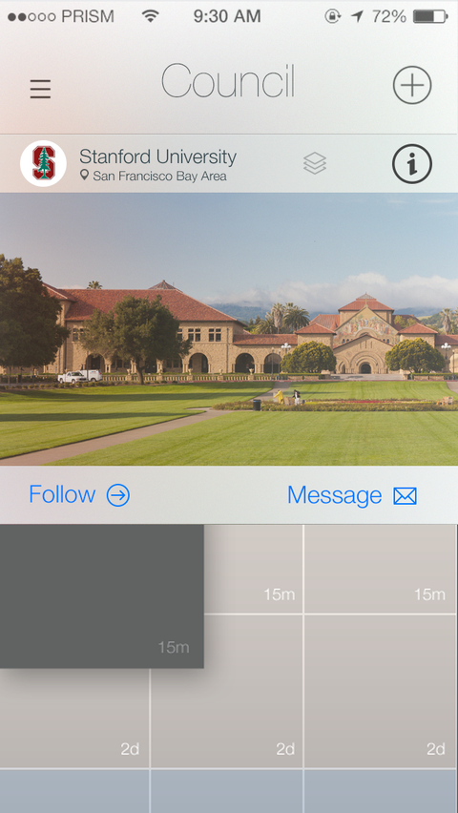 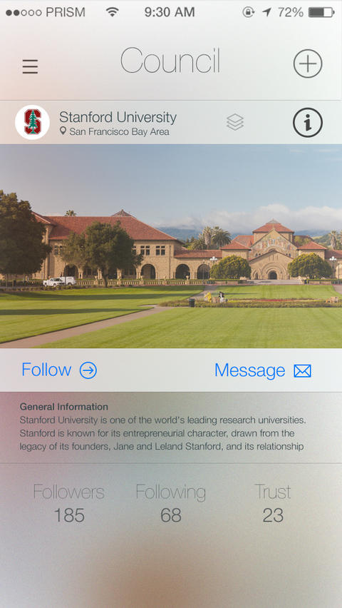

**Sign-up**[[f]](https://docs.google.com/a/higheraltitude.co/document/d/1TPzunpdWq_1FrTwE8zpSQYDXbfBfsiRwWasSudvW-zY/mobilebasic#cmnt6)

Initial sign-up can be done through “Facebook Connect” or manually by entering the required information fields for their selected profile type. All users are initially given a standard profile.

The following information is required for a standard Profile:

* First Name (required)
* Last Name (required)
* Email Address (required)
* Zip code (required)
* Sex (required)
* Age? (Birthdate) (required) [[g]](https://docs.google.com/a/higheraltitude.co/document/d/1TPzunpdWq_1FrTwE8zpSQYDXbfBfsiRwWasSudvW-zY/mobilebasic#cmnt7)
* Bio – short description (optional)
* School/Employment (optional)
* Race/Ethnicity (optional)
* American Indian/Native American
* Asian
* Black/African American
* Hispanic/Latino
* White/Caucasian
* Pacific Islander
* Multiracial
* Other

After signing up for a standard profile, there will be an option to apply to be an Institution[[h]](https://docs.google.com/a/higheraltitude.co/document/d/1TPzunpdWq_1FrTwE8zpSQYDXbfBfsiRwWasSudvW-zY/mobilebasic#cmnt8). Upon completion their application, their profile will be tagged in the CMS as awaiting approval. The following information is required for an Institution Profile:

* Institution Name
* Administrator First Name
* Administrator Last Name
* Email Address
* Website
* Address
* Luminaries

If the user chooses to Connect with Facebook, they will be asked for a Zip Code.

**Share - Post/RePost**

The share page will allow a user to post or repost content. The user will also be able to fill out the following information to each post:

* Picture of content (standard iOS 7 camera)
* Map
* Tag another user.
* Hashtag content.
* Select private or public
* Select social networks to share.
* Select category for post.

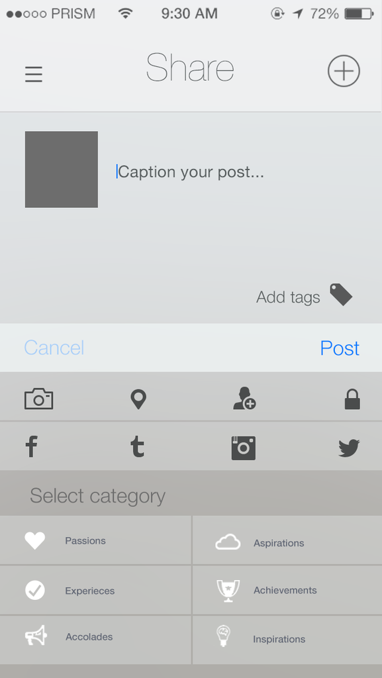

**App additions for Council Members**

Council Version of the app needs to include the following:

Luminaries management page to replace the trust section

Profile page will be amended to include Admins and user data added

Insights similar to other networks to include

Total Followers

New Followers

Total Reach to the community

Individual Post reach to community

Engagement – likes, comments, shares, add to prism, post clicks (click through)

**Developer Notes**

* Update Notifications - choose between:
* Force-update
* Lock older versions of the app
* Update Reminders
* A notice that appears in the app (on both cold and warm boots) notifying the user that a new version is available in the app store and linking the user to the app store if they click “ok” or dismissed temporarily if they click “ignore”.
* Appears 1st, 2nd, 5th, and 10th time the user loads the app
* Arbitrary push notifications
* The ability to push a message to all current app users. This push notification can be operated via a secure CMS.
* Analytics for standard tracked actions & metrics
* opens per month
* active monthly users
* devices & os versions
* session length
* # of push notifications sent
* conversion funnels for top in-app activities
* screen flows
* feature usage, content access, ad performance
* Errors & Messages
* No Connection: “Your device appears to be disconnected from the internet. Please reconnect and try again.”
* Connection error: “Looks like you’re having trouble connecting to the server. Please try again in a moment. :(”
* The system is currently down. We know. Be back soon. :(
* this is CMS-defined
* Validation on any input forms
* Loading
* Splash screen
* Loading indicators when fetching new information
* Uploading indicator if content is being uploaded
* App works on iPhone 4 & 5 screen sizes
* App gracefully handles a shrunken screen during a phone call or VOIP call (when the screen gets scrunched)
* All app data transmitted over the internet should be encrypted with a cert signed by a third party.
* iOS
* For iOS apps, we build apps that support the latest version of iOS if it has greater than 70% adoption rate as measured by Onswipe, Chartboost, Chitika, or similar and will use whichever shows the greatest penetration of the newest OS. Otherwise we will support the two latest major releases (e.g. iOS 6 and 6.1)
* Resolutions (iPhone app: retina only; iPad: we only support the two most recent device iterations)

**Tutorial Screens**

Upon opening the app for the first time the user will be shown a series of screens demonstrating the functionality of the app[[n]](https://docs.google.com/a/higheraltitude.co/document/d/1TPzunpdWq_1FrTwE8zpSQYDXbfBfsiRwWasSudvW-zY/mobilebasic#cmnt14)p

**V2**

* Recommend institutions based on similar users likes
* Calendar – event reminders